Steve Cahill, Marcus Reese, Zac Kruger

Including the name of our application and a short description here.

Project Plan

CSC442B - Group 8 - Simpletons

# Scope Statement

## Problem Statement

English is a complex language, and deciphering word meaning is a tough undertaking. A recent Harvard University/Google joint study pointed to a count of words in the English language at over 1,000,000, and that the size of the language has more than doubled in the last 100 years. Given that the average vocabulary for a native speaker is between 5,000 and 10,000, and the vocabulary for a non-native English speaker is much lower, participants in this language will frequently encounter words that must be simplified in order to improve understanding.

## Project Goals

This project seeks to develop an English language simplifier, where one can input English text, and then receive output of a simplified version of that text.

The simplification will occur using some defined lists of words, their synonyms, and properties such as “reading level.” Some of these lists already exist, such as “Simplified English,” the “Oxford 3000,” and “Common 5000.”

Stretch Goal: branch into some sections of grammatical simplification. This may pose too large of a problem to tackle in a one semester project, as it requires heavy knowledge of sentence syntax and linguistics.

## Communication Plan

The project team will meet as a group at least once weekly to discuss progress and next steps. These meetings will likely be via Skype, but we’ll play this by ear.

Between meetings, the project team will stay abreast of each other’s progress via email.

Decisions will be made collaboratively, but each team member will have leeway to fulfill their objectives as they see fit.

## Project Deliverables

### Project Plan

This document

### Programmer’s Manual

Includes documentation for Requirements, Design, Testing, Source Code, and known bugs and issues.

### User Documentation

Includes user’s manual and usage instructions

### Application

To be accessed via URL

## Software Boundaries

The application will be a web-browser-based user interface, focusing on compatibility with recent versions of Google Chrome. Time permitting, we’ll include other modern HTML5 browsers.

The application will interact with some natural language processing software, such as stemmers, part-of-speech taggers, and chunkers, and will use pre-defined databases of word lists such as WordNet to enact the substitution.

## High-Level Milestones

### Requirements Brainstorm

12-Feb-13 to 20-Feb-13

### Design

21-Feb-13 to 27-Feb-13

### Development/Testing Iterations

28-Feb-13 to 17-Apr-13

### Alpha Release

18-Apr-13

### Beta Release

26-Apr-13

### Public Release

3-May-13

# Org Chart

## Client/UI Developer

Marcus Reese

## Server/API Developer

Zac Kruger

## Project Manager

Steve Cahill

# Gantt Chart/Detailed Schedule

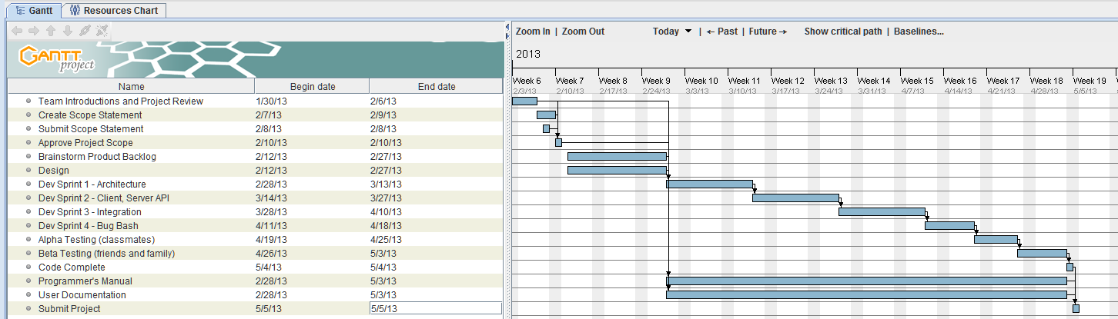

# Tools and Standards

## Process Model

The team will use an iterative development model with a modified version of Scrum. The project will proceed with Sprints approximately two weeks in length, but Scrums will occur weekly, rather than daily.

## Documentation Standards

Doxygen

## Coding Standards

### API

JSON

## Programming Languages

### Client-Side

#### JavaScript

Templating: DoT

Testing: Mocha

UI and AJAX: jQuery and jQueryMobile

Stringify/Parse: json2.js

File Management: fileSaver.js

Part-of-Speech Tagging: pos-js (https://github.com/fortnightlabs/pos-js)

#### HTML/CSS

### Server-Side

## Editors/IDE(s)

Notepad++

## Release License

MIT

## Source Control

Github or Launchpad

## Web Hosting

Zac’s personal webserver

## Other Tools

### Design

OpenOffice.org Draw

### Web Browser

Google Chrome

### Communication

Skype

Google Drive

Email

## Third-Party Data Sources

### WordNet

WordNet provides a rich dictionary of all English words and their synonyms.

### Simplified Word Lists

#### Specialized English

[www.spotlightradio.net](http://www.spotlightradio.net)

#### Oxford 3000

[www.oxfordlearnersdictionaries.com](http://www.oxfordlearnersdictionaries.com)

#### Dolch Words

[www.enchantedlearning.com/dolch](http://www.enchantedlearning.com/dolch)

#### GSL

[www.jbauman.com/gsl.html](http://www.jbauman.com/gsl.html)

#### 5000 Most Common Words

[www.englishclub.com](http://www.englishclub.com)

# Version Control Plan

## Sprint 1

0.1.<build_number>

## Sprint 2

0.2.<build_number>

## Sprint 3

0.3.<build_number>

## Sprint 4 – Bug Bash/Usability

0.4.<build_number>

## Alpha Release

0.5.<build_number>

## Beta Release

0.6.<build_number>

## Production Release

1.0

## Post-Production Versioning

### Major Update

Increment the major version, e.g. 2.0, 3.0

### Minor Update

Increment the minor version, e.g. 1.1, 1.2, 1.3